ANNEX 9.1
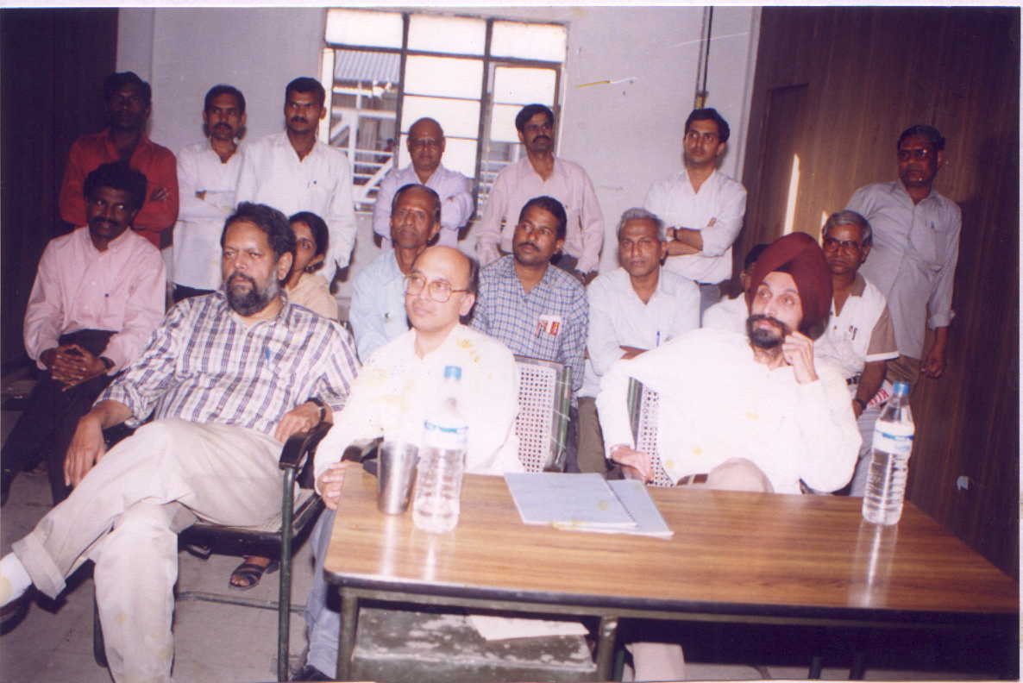
Photographs of Public Consultation

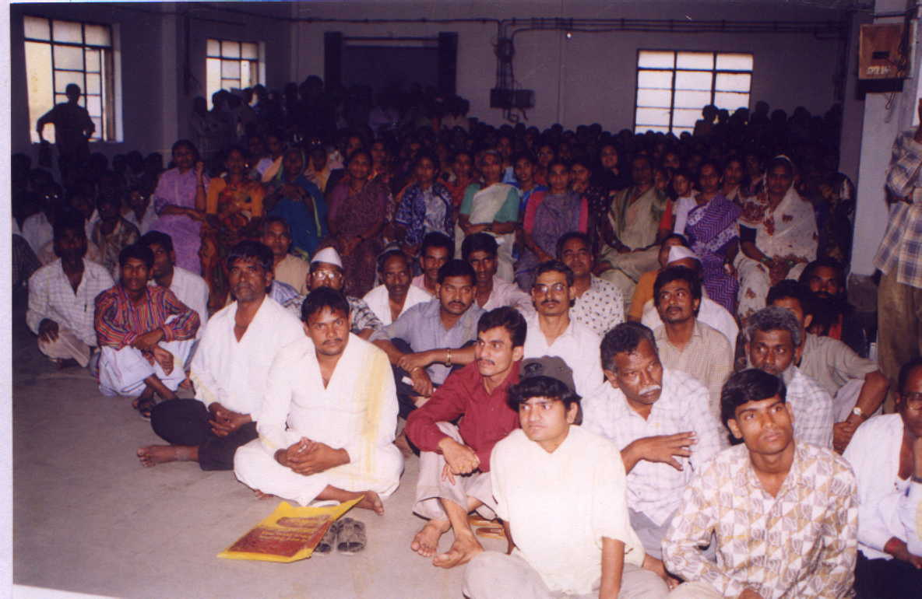

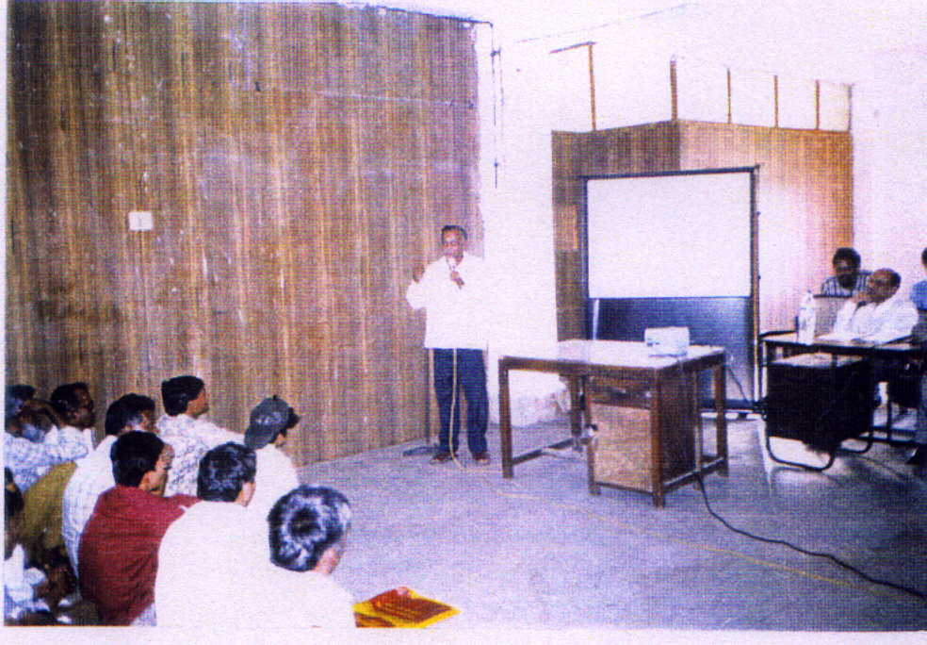

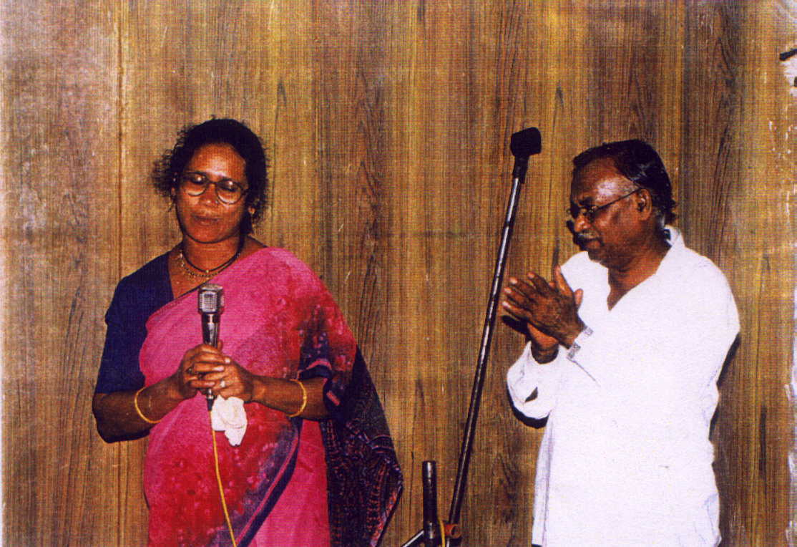

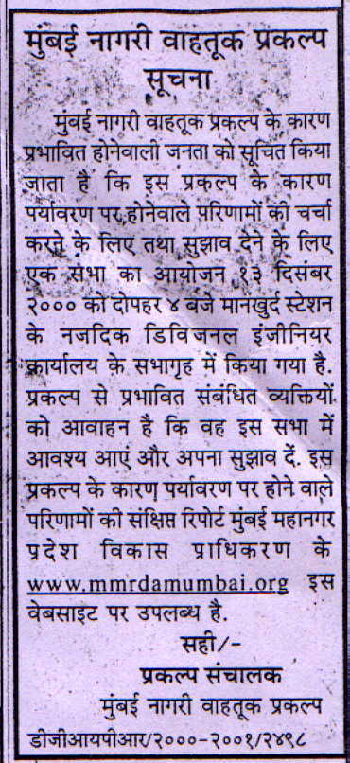
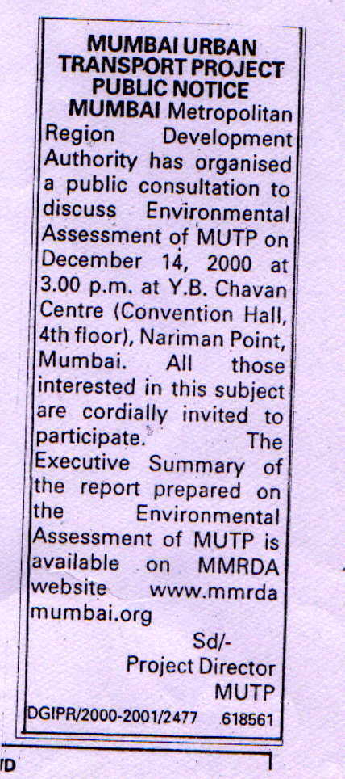
Advertisements published in the Newspapers

Pamphlets
MUMBAI URBAN TRANSPORT PROJECT

PUBLIC NOTICE

Mumbai Metropolitan Region Development Authority has organised a public consultation to discuss Environmental Assessment of MUTP on December 13, 2000 at 4.00 p.m. at Mankhurd Station Near Office of the Divisional Engineer (Convention Hall ) Mumbai. All those interested in this subject are cordially invited to participate. The Executive Summary of the report prepared on the Environmental Assessment of MUTP is available on MMRDA Website www.mmrdamumbai.org

Project Director
MUTP

MUMBAI URBAN TRANSPORT PROJECT

PUBLIC NOTICE

Mumbai Metropolitan Region Development Authority has organised a public consultation to discuss Environmental Assessment of MUTP on December 14, 2000 at 3.00 p.m. at Y.B. Chavan Center (Convention Hall, 4th floor), Nariman Point, Mumbai. All those interested in this subject are cordially invited to participate. The Executive Summary of the report prepared on the Environmental Assessment of MUTP is available on MMRDA Website www.mmrdamumbai.org

Project Director
MUTP

